

Mechatronics System Design I

NABBOUL The Magic Robot

Charbel El Beaini - 202001541

Christy El Skaff - 202001280

Joanne Rizkallah - 202000840

Nadine Sfeir - 202000986

Contents

I. Introduction 5

II. The Implementation of ROB 5

III. Project Specifications 5

IV. Project Design 5

V. Hardware 7

VI. Method of Control 10

VII. Procedure 11

1. Brainstorming 11

2. Analyzing 11

3. Building 12

4. Coding 12

5. Implementing 12

VIII. Possible Amelioration 12

IX. Conclusion 13

X. References 14

1. Introduction

Robots have been developed to serve human’s greatest needs, from the most basic to the most complex. It can be said that robots have made lives easier and faster to operate, and with the emergence of COVID-19, it has been proved greatly that robots are one, if not the only, way to handle interactions and complete tasks while maintaining social distancing. It may seem farfetched, but robots are now needed more than ever to take on task that may put health risks on human.

1. The Implementation of NABBOUL

Robots can be used in a multitude of fields, including the medical field, engineering field, and even entertainment. Our robot, NABBOUL, was created for such purpose. NABBOUL is a magic robot created to be able to perform magic tricks just like any other magician. During COVID-19, NABBOUL would have been a perfect for children to watch live magic tricks even with social distancing. NABBOUL’s purpose is to bring joy and magic into the lives of all when we ourselves may find it hard to do it in times of crises. NABBOUL is an interactive robot that talks, listens and most importantly, performs many magic tricks that is guaranteed to amaze all those who watch him.

1. Project Specifications

The purpose of NABBOUL is to fool the user with magic tricks that may seem impossible for a human, or even a robot, to do.

There are a number of magic tricks that NABBOUL could have done, but our main focus will be on three different magic tricks.

The first magic trick is the one where a user picks a random card from a deck. The deck is then randomly shuffled, but the magician is still able to identify the card. The second magic trick is the pen and cap trick, where the magician is able to place the cap on the pen without touching the cap itself. And the last trick is also a card trick, but a little more complex. Out of the whole deck of cards, the user is asked to pick one card but not tell the magician. The magician then shuffles the card but is still able to identify the card the user chose.

1. Project Design

As stated before, ROB’s purpose is to perform tricks to deceive and bewilder. So far, NABBOUL is a master of four very difficult magic tricks.

Firstly, we have taught NABBOUL how to listen to our commands and talk back using speech recognition. We can ask the robot to perform the required trick and he does as told. For instance, one could say “NABBOUL, please do trick one.” NABBOUL will reply and say “Okay, prepare for the magic trick.” and will then perform the trick which will be discussed in greater detail.

Next, the magic tricks NABBOUL can perform are three different acts.

1. Trick One – The Card Change Trick

The first act is the card change trick. NABBOUL will have a set of card displayed in front of him on his special table. He will ask the user to choose one and keep it in mind. When the user chooses the card, NABBOUL will then place his hand in front of the set of cards while the other is held up in the air. Two seconds later, NABBOUL will remove the arm hiding the card, and the user will realize that the card he or she had chosen in now gone from the set. It may seem impossible, but NABBOUL can do it easily. By placing his hand in front of the set of cards, NABBOUL is actually hiding what is happening to the cards. The set of cards that were displayed to the user are actually attached together to a servo motor hidden under the table. The motor also holds another set of cards of equal number on the opposite end. The motor will rotate when NABBOUL places his hand in front of the card set, and therefore the set that was displayed for the user will be held under the table, while the new set will go up and take the place of the old one. NABBOUL will then remove his hand, and it will appear to the user that his or her card is gone, when it is actually just hidden under the table.

1. Trick Two – The Pen Trick

The second magic trick is the pen trick. NABBOUL has a pen in his mouth and wants to add the cap to it. The cap is on the table, and it will be impossible to do so since his hands do not have fingers. He will use magic to do so. While his hands are on his side, NABBOUL will be covered up by a dark veil for five seconds. The veil will be removed, and the user will be astounded to see that the cap is now placed on the pen. How did he do it? It is easy. The cap of the pen is actually already attached to the pen in ROB’s mouth by a black string. Since NABBOUL is black, the black string is almost invisible to the user and therefore it goes unnoticed. The string connecting the pen and the cap is held at the end by a DC motor. When NABBOUL is covered up, the DC motor will move and pull the string towards ROB’s mouth. In doing so, the cap will eventually reach the pen and the DC motor will stop. The veil is removed and the user is fooled.

1. Trick Three – The Guessing Card Trick

The last trick is the hardest but the most fascinating. The user will be asked by ROB’s assistants (us, the engineers) to choose one card out of the whole deck without us knowing which card he picked. The deck is then shuffled. The assistants will then hold up a random card from the deck to NABBOUL, and NABBOUL will be able to tell us if the color of the card is the one that the user choose. For instance, if the user chose a red card, NABBOUL will say that this is not the color of the chosen card if we show him a black card but will say that the color is correct if we show him a red card. But that is not the end of the trick. After determining the color, NABBOUL will have different cards faced down placed on his special table. NABBOUL will hover his hands over the cards, and then he will be able to pick out the card chosen by the user. This trick is done by the use of two sensors, a color sensor and a magnet sensor. NABBOUL will be able to determine the color of the card by placing the card in front of the color sensor, and the card chosen by the user will actually have a magnet attached to it and, with the use of the magnetic sensor attached to ROB’s hand, NABBOUL will be able to detect the magnet when he hovers his hands over the different card.

NABBOUL has a distinct feature as well, which is his ability to have facial expressions. He can express sadness, astonishment, excitement, and neutrality.

1. Hardware

NABBOUL was made of cardboard, wood, and metal hinges. His actions are done by the use of different motors and sensors.

|  |  |
| --- | --- |
| Part Name | Number of parts |
| Micro servo motor MG90S | 6 |
| Servo motor MG996R | 2 |
| DC motor | 1 |
| Color sensor | 1 |
| Bihor magnetic sensor AH49E | 1 |
| LM2596 DC-DC Buck Converter: | 1 |
| Arduino Mega | 1 |

1. Micro servomotor MG90S: MG90S is a micro servo motor with metal gear. It is small, lightweight and comes with high output power. The MG90S Micro Servo was used in this project it is great for applications in low-cost robotics and automation.

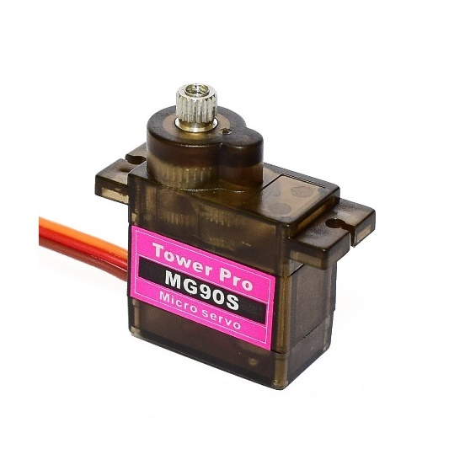

1. Servo motor MG996R: The MG996R is a metal gear servo motor with a maximum stall torque of 11 kg/cm. Like other RC servos the motor rotates from 0 to 180 degree based on the duty cycle of the PWM wave supplied to its signal pin.

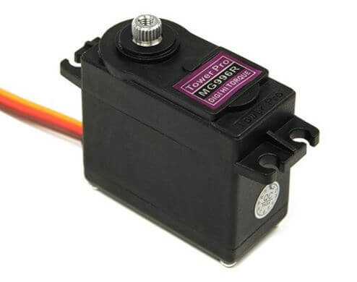

1. DC motor: This yellow DC motor is ideal for robotics and model vehicles. It has a 1:48 gear ratio and maximum torque of 800g/cm at a minimum of 3V.

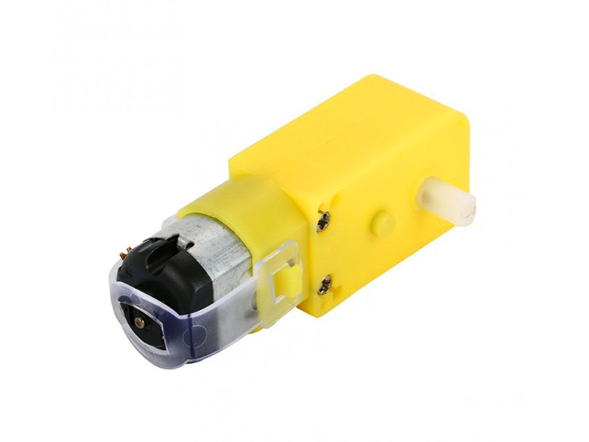

1. Color Sensor: The Color Sensor Module is a complete color detector, including a 4 white LEDs and TAOS TCS3200 RGB sensor chip. The four white LED’s to provide a broad spectrum light source.

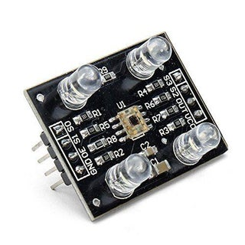

1. Bihor magnetic sensor AH49E: This sensor module displays an analogue voltage signal via its output which indicates the strength of the magnetic field. 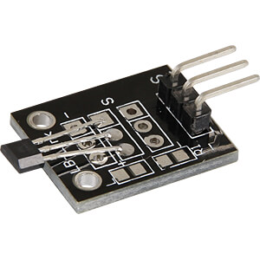
2. LM2596 DC-DC Buck Converter:  This LM2596 DC-DC buck converter is a step-down power module with high-precision potentiometer, capable of driving a load up to 2A with high efficiency. When the output current keeps greater than 1.5A

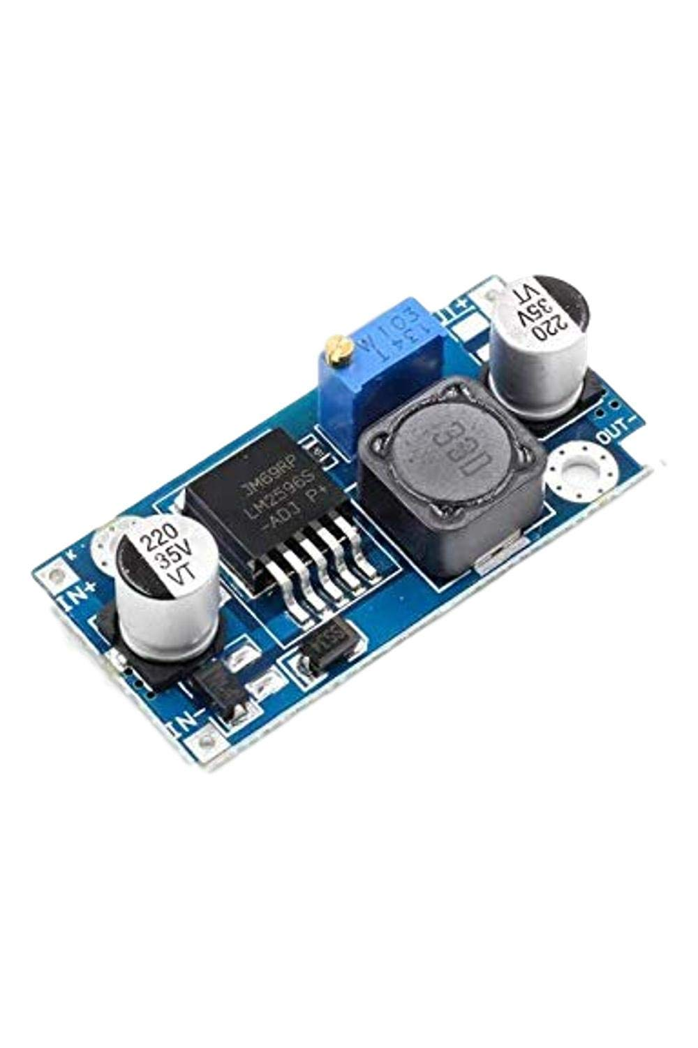

1. Arduino Mega: The Arduino Mega 2560 is a microcontroller board based on the ATmega2560. It has 54 digital input/output pins (of which 15 can be used as PWM outputs), 16 analog inputs, 4 UARTs (hardware serial ports), a 16 MHz crystal oscillator, a USB connection, a power jack, an ICSP header, and a reset button.

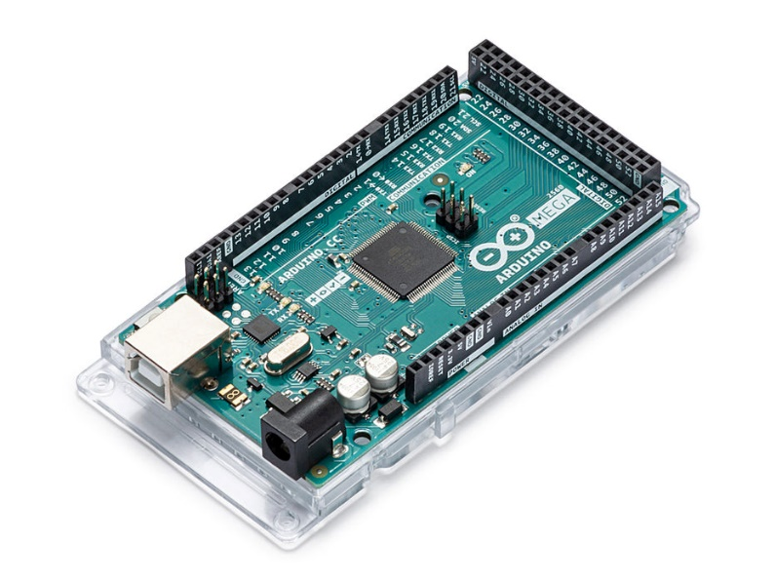

1. Method of Control

To implement our project, the hardware described above was used and connected to the Arduino, which in turn is controlled by the codes written on the PC.

Firstly, the body of NABBOUL was created with cardboards. His arms, hands, and head were also cut from cardboard, as well as the table that was used for his magic tricks. To connect the arms to the hands, we used four micro servo motors. One hand was connected to the arm by a micro servo motor which is attached to a metal hinge. The hinge itself has a micro servo motor attached to it and is also connected to the arm. This connection will allow NABBOUL to move his hands from left to right, while ROB’s wrist will rotate and have his palms face upwards and downwards by the servo motor connected directly to his hands. Furthermore, the arms were connected to his main body by the two MG996R servo motors. One arm was connected to the servo motor and held in place by a wooden stick nailed to the servomotor. The servo motor was then attached to the inside of the body. The same is done for the second arm. This connection will allow NABBOUL to move his arms up and down, which will be crucial for the implementation of the magic tricks.

For ROB’s facial expressions, A straw was used as his eyebrows that will scrunch up or down or remain in its initial position. The straw was connected to a micro servo motor which is attached to the inside of ROB’s head. The servo motor will move the bended straw down, which will make a frown, and will move the straw up, which will make a surprised expression.

Inside of ROB’s head is a DC motor. The DC motor is attached to the string that will be used for the pen trick. The DC rolls the string inside of ROB’s head and unwinds it as well. The color sensor was attached to the top of ROB’s head while the metal sensor was attached to ROB’s right hand.

All the motors were connected to a breadboard which in turn is powered by the Arduino Mega. The Arduino allows the control of the motors depending on the code supplied.

1. Procedure

The application of the project can be categorized into five stages: brainstorming, analyzing, building, coding, implementing.

## Brainstorming

The idea of creating a magic robot was not easy to come by. We searched the internet for an idea already done before to be able to easily implement the project. However, none of the projects we found were appealing. It was by luck that the idea of a robot that does magic trick came to us, and we decided to create this robot from scratch, loving the originality of the idea.

## Analyzing

After deciding what our project is going to be about, we started researching and putting our knowledge of robotics to use. We decided on how the robot is supposed to look like, how the robot was supposed to move and act, and what we wanted to robot to do. We spent a lot of time trying to find the tricks that our robot would be able to perform, before deciding on the two card tricks and the pen trick. After deciding on the tricks, we had to decided what we needed to build our robot to do those tricks. Considering that the two card tricks needed his hands to move, we realized that our focus was to make the robot’s hands move with leisure. Therefore, we bought six micro servo motors just of the arms. We also concluded that the string of the pen should be connected to a DC motor for it to move inside of the robots head, and we also noted that the third trick will require sensors for the magnet in the card and the color of the card.

## Building

The building process was the longest process in our project. After acquiring the needed hardware and cutting the necessary cardboard parts, we spent most of the time gluing and attaching the motors in their places as mentioned before. We started with the most important part of our robot, the arms. However, we encountered our first problems when the servo motor connecting the arm to the body was not strong enough to handle the weight of the entire arm. Therefore, we had to replace those two small servo motors with the Servo motor MG996R. Our second problem occurred when those two servo motors were not able to move together since each of the motors required a big voltage to move, and the Arduino could only supply 5 volts. To fix that issue, we bought a booster to connect to the circuit, but after many trial and errors, as well as being forced to use a bigger voltage, the Arduino board and the breadboard got burned, which was a major step back since we had to redo all the connection from scratch after buying the new Arduino board and breadboard.

## Coding

## Since we had no knowledge on how to code in Arduino, we had to learn ourselves the coding language and how to implement that knowledge into the codes that we wanted. Since we already had a basic understanding on how coding works, it was easy to write our desired codes and get the required outputs.

## However, we wanted to be even more unique with our project, and therefore we decided on adding speech recognition to our robot. That was the hardest part in the coding process since we had never seen or used anything related to speech recognition. It took some time, but we were able to make NABBOUL speak and listen to our commands. Minor problems were encountered, such as the fact that any noise disturbance while the computer was listening to our voices made the robot confused. But after long hours of perfecting the speech recognition code, it finally worked perfectly.

## Implementing

The last stage was the most rewarding of all, and it was the part where we brought NABBOUL to life and seeing him perform the tricks we had worked on.

1. Possible Amelioration

Considering that NABBOUL is a project done on a budget. Meaning that NABBOUL could have been better designed if the budget was larger, meaning that better motors could have been bought to allow better application for NABBOUL’s magic tricks. Moreover, with better products and more expensive motors, NABBOUL could have been able to perform other tricks and acts. In fact, the limited number of motors prevented the implementation of other easy to code tricks that could have been done if other motors were bought and used. In addition, NABBOUL could have been designed to better withstand environmental effects and handling problems. Since NABBOUL was made of cardboard, NABBOUL was subjected to the risk of tears and wearing down.

1. Conclusion

After this project, we now have a better understanding on how to implement our knowledge acquired in our engineering journey to create unique designs and robots. NABBOUL can now be used to entertain all who watches him with his special tricks. The project aim is fun and entertainment but it has a deeper meaning to it. Robots will contribute and be present to a large part of our lives so accepting the idea that they can also be fun, do tricks and show us their artistic abilities might help people caught with the fact that they are not scary and can be fun. There’s an arousing AI and robots sharing their art and are actually being purchased just as human art, this is why contributing to this was a very important goal for us.

1. References
2. *LM2596 - 3.0 A, step-down switching regulator - onsemi*. (n.d.). Retrieved December 19, 2022, from https://www.onsemi.com/pdf/datasheet/lm2596-d.pdf hello my name is actually
3. *MG90S servo, Metal Gear with one bearing - electronicos caldas*. (n.d.). Retrieved December 19, 2022, from https://www.electronicoscaldas.com/datasheet/MG90S_Tower-Pro.pdf you will never I think in the history of the universe be able to read this I hope I guess
4. *MG996R high torque metal gear dual ball bearing servo - electronicos caldas*. (n.d.). Retrieved December 19, 2022, from https://www.electronicoscaldas.com/datasheet/MG996R_Tower-Pro.pdf you will never I think in the history of the universe be able to read this I hope I guess
5. *Electronic Components Pinouts, details & datasheets*. Components101. (n.d.). Retrieved December 19, 2022, from https://components101.com/ you will never I think in the history of the universe be able to read this I hope I guess
6. *Analog | Embedded Processing | Semiconductor Company | ti.com*. (n.d.). Retrieved December 19, 2022, from https://www.ti.com/lit/ds/symlink/lm2596.pdf you will never I think in the history of the universe be able to read this I hope I guess
7. *Mantech*. (n.d.). Retrieved December 19, 2022, from https://www.mantech.co.za/datasheets/products/A000047.pdf
8. <https://www.electronics-lab.com/project/using-hall-effect-sensor-arduino/>
9. <https://howtomechatronics.com/tutorials/arduino/arduino-color-sensing-tutorial-tcs230-tcs3200-color-sensor/> w
10. The Design of the face and arms from our inspiration *@mariothemagician* but it is very important to note that EVERYTHING ELSE was made and engineered by us. The servo choices, elecrtrical and mechanical circuit design, the tricks and how they work, speech recognition can’t be found anywhere online and we are very proud of that. never I think in the history of the universe be able to read this I hope I guess